Mental Health Month: Social Media Calendar
This May, to spread awareness and promote Mental Health, we encourage sharing all of the provided content to your city’s or organization’s social media profiles throughout the month. The files for each image can be found on our website for your use.
All of the content shown in this guide will be shared across San Mateo County Health’s social channels, which give the option to reshare as well.
San Mateo County Health’s social channels:
- Facebook
- Instagram
- Twitter
Suggested Posting Schedule
Below is the content for each platform (Instagram, Facebook, and Twitter). Feel free to include additional hashtags catered to your city or organization.

Instagram
April 28 | May 1
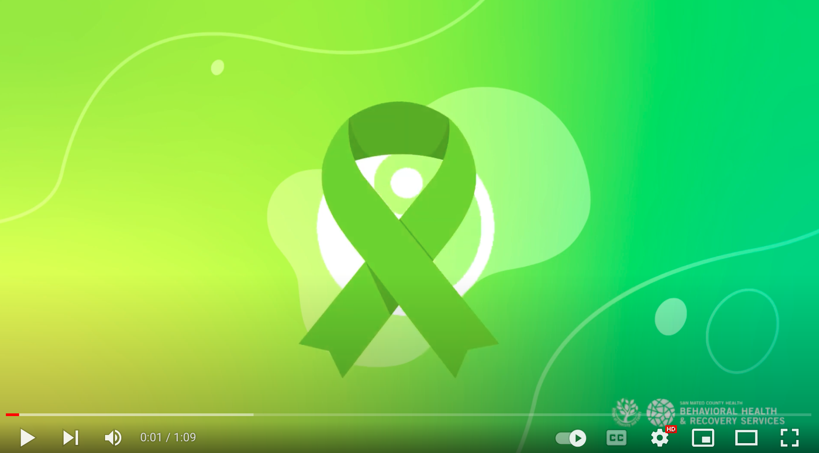  https://youtu.be/NbgPe84xw2A  May is Mental Health Month and California’s theme this year is Take Action! That means takes action to improve your and your love ones’ mental health. Follow us throughout the month to learn more about how to take action for mental health.  For our full list of free and public events and mental health resources, visit smcmentalhealthmonth.org.  #SMCTakeAction4MH | 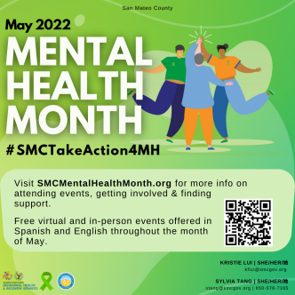  May is #MentalHealthMonth! You can take action for mental health by finding out how to #CheckIn, #LearnMore, and #GetSupport for yourself or anyone you know who is in a mental health crisis. Visit smcmentalhealthmonth.org for local resources!  #SMCTakeAction4MH
May 3 | May 6
For #MentalHealthMonth, you can take action for mental health by finding out how to #CheckIn on your mental health and the mental health of those you care about. Start a conversation to see how you can help or support yourself and others. Find out how at smcmentalhealthmonth.org  #SMCTakeAction4MH | [StarVista Post coming soon!]
May 10 | May 13
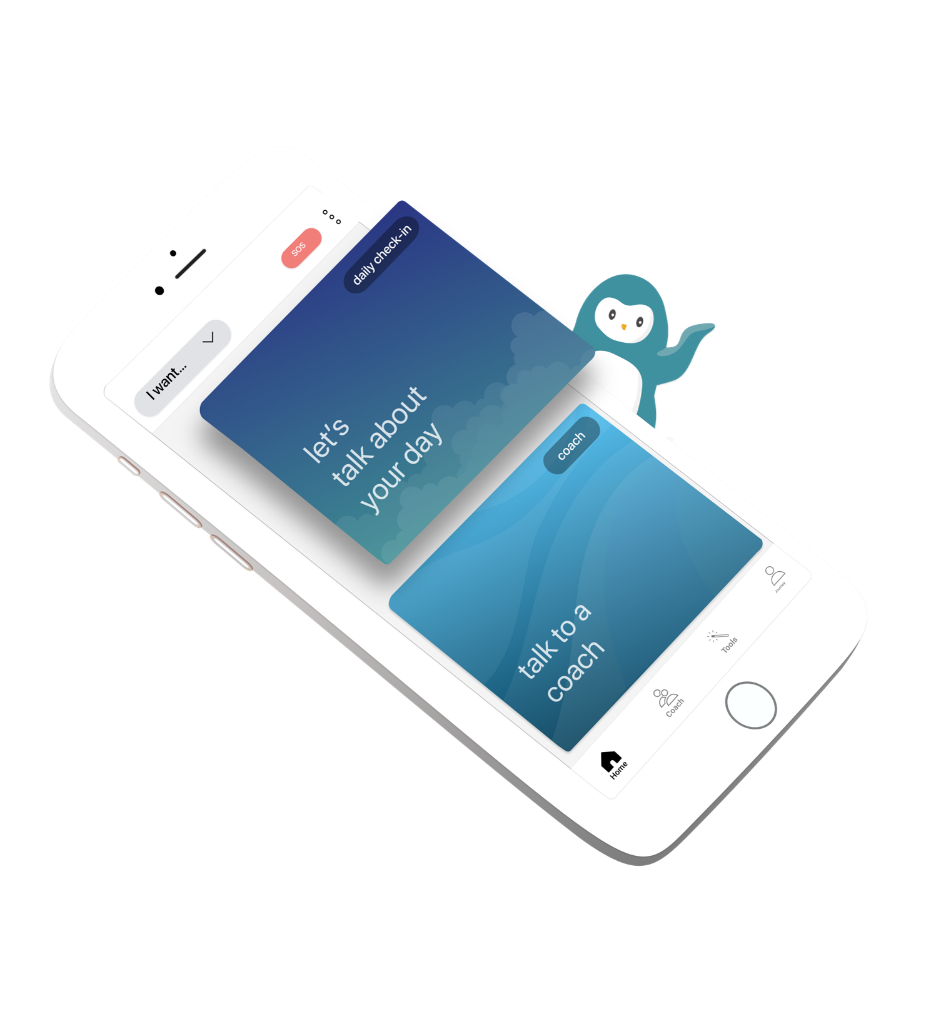  WYSA is our brand new wellness chatbot, available 24/7 to you for free, anytime, anywhere. It is anonymous and uses evidence-based cognitive-behavioral techniques (CBT) to respond to the emotions that you express.  WYSA has over 150+ self-care tools that cater to different areas of mental wellness! Create your non-judgmental safe space with WYSA!  Get your free subscription here!  For info about Mental Health Month visit smcmentalhealthmonth.org.  #SMCTakeAction4MH | Here's another action you can take for #MentalHealthMonth: #LearnMore about mental health needs and explore the self-care, services, and supports available to help find a path forward. Visit smcmentalhealthmonth.org to get started. #SMCTakeAction4MH
May 17 | May 20
#GetSupport for your own mental health, or help someone else find help, by reaching out and connecting with resources available in San Mateo County! Visit smcmentalhealthmonth.org for helpful resources.  #SMCTakeAction4MH | 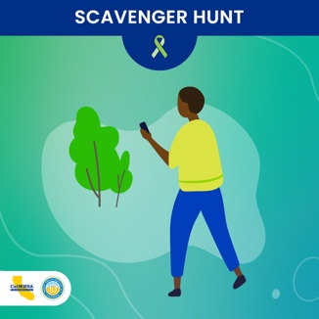  Join the #MentalHealthMattersMonth Scavenger Hunt! Get outside and discover places and activities that can help you engage in #SelfCare or support others. Visit takeaction4mh.com (or link in bio) for details.  #SMCTakeAction4MH
May 24 | May 27
https://youtu.be/NbgPe84xw2A  There’s still time to support your communities’ mental wellness! May is Mental Health Month and California’s theme this year is Take Action! That means takes action to improve your and your love ones’ mental health.  Learn more about ways you can take action by visiting smcmentalhealthmonth.org.  #SMCTakeAction4MH | 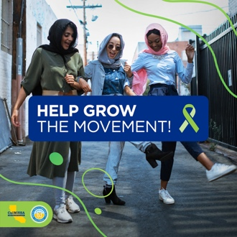  Help grow the movement to Take Action For Mental Health in California! Suggest us as a follow to friends and family, pledge to take action, and show your support for people experiencing a crisis this Mental Health Matters Month — and every month! #MakeThePledge #SMCTakeAction4MH
May 31
[Thank you for celebrating MHM post coming soon!]

Facebook
April 28 | May 1
https://youtu.be/NbgPe84xw2A  May is Mental Health Month and California’s theme this year is Take Action! That means takes action to improve your and your love ones’ mental health. Follow us throughout the month to learn more about how to take action for mental health.  For our full list of free and public events and mental health resources, visit smcmentalhealthmonth.org.  #SMCTakeAction4MH | 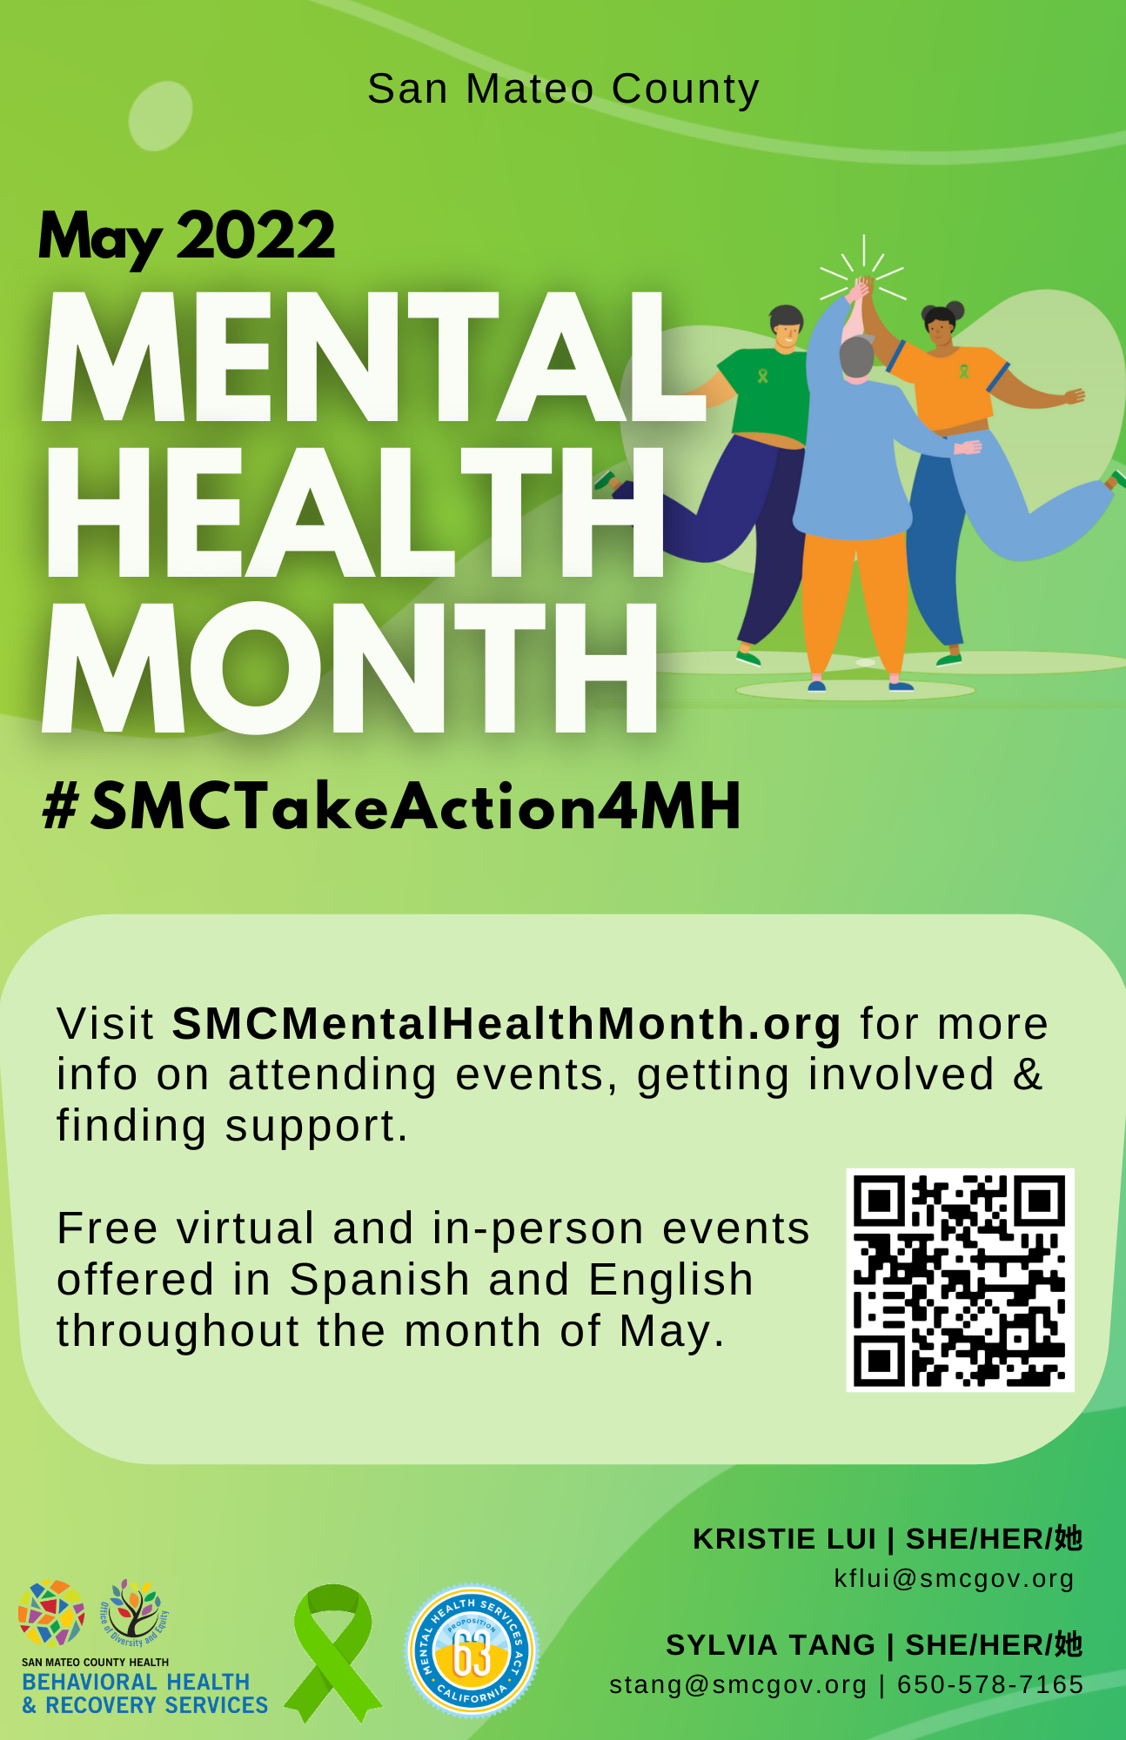  May is #MentalHealthMonth! You can take action for mental health by finding out how to #CheckIn, #LearnMore, and #GetSupport for yourself or anyone you know who is in a mental health crisis. Visit smcmentalhealthmonth.org for local resources!  #SMCTakeAction4MH
May 3 | May 6
For #MentalHealthMonth, you can take action for mental health by finding out how to #CheckIn on your mental health and the mental health of those you care about. Start a conversation to see how you can help or support yourself and others. Find out how at smcmentalhealthmonth.org  #SMCTakeAction4MH | [StarVista Post coming soon!]
May 10 | May 13
WYSA is our brand new wellness chatbot, available 24/7 to you for free, anytime, anywhere. It is anonymous and uses evidence-based cognitive-behavioral techniques (CBT) to respond to the emotions that you express.  WYSA has over 150+ self-care tools that cater to different areas of mental wellness! Create your non-judgmental safe space with WYSA!  Get your free subscription here!  For info about Mental Health Month visit smcmentalhealthmonth.org.  #SMCTakeAction4MH | Here's another action you can take for #MentalHealthMonth: #LearnMore about mental health needs and explore the self-care, services, and supports available to help find a path forward. Visit smcmentalhealthmonth.org to get started. #SMCTakeAction4MH
May 17 | May 20
#GetSupport for your own mental health, or help someone else find help, by reaching out and connecting with resources available in San Mateo County! Visit smcmentalhealthmonth.org for helpful resources.  #SMCTakeAction4MH | Join the #MentalHealthMattersMonth Scavenger Hunt! Get outside and discover places and activities that can help you engage in #SelfCare or support others. Visit takeaction4mh.com (or link in bio) for details.  #SMCTakeAction4MH
May 24 | May 27
https://youtu.be/NbgPe84xw2A  There’s still time to support your communities’ mental wellness! May is Mental Health Month and California’s theme this year is Take Action! That means takes action to improve your and your love ones’ mental health.  Learn more about ways you can take action by visiting smcmentalhealthmonth.org.  #SMCTakeAction4MH | Help grow the movement to Take Action For Mental Health in California! Suggest us as a follow to friends and family, pledge to take action, and show your support for people experiencing a crisis this Mental Health Matters Month — and every month! #MakeThePledge #SMCTakeAction4MH
May 31
[Thank you for celebrating MHM post coming soon!]

Twitter
April 28 | May 1
https://youtu.be/NbgPe84xw2A  May is Mental Health Month and CA’s theme this year is Take Action! Takes action to improve your and your love ones’ mental health. Learn how to take action for mental health at smcmentalhealthmonth.org.  #SMCTakeAction4MH | May is #MentalHealthMonth! You can take action for mental health by finding out how to #CheckIn, #LearnMore, and #GetSupport for yourself or anyone you know who is in a mental health crisis. Visit smcmentalhealthmonth.org for local resources!  #SMCTakeAction4MH
May 3 | May 6
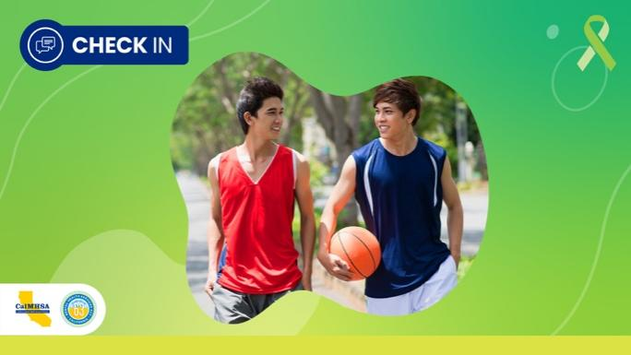  For #MentalHealthMonth, you can #SMCTakeAction4MH! #CheckIn on your mental health & the mental health of those you care about. Start a conversation to see how you can help or support yourself or others. Find out how at smcmentalhealthmonth.org! | [StarVista Post coming soon!]
May 10 | May 13
WYSA is our brand new wellness chatbot, available 24/7 to you for free, anytime, anywhere. It is anonymous and uses evidence-based cognitive-behavioral techniques (CBT) to respond to the emotions that you express.  WYSA has over 150+ self-care tools that cater to different areas of mental wellness! Create your non-judgmental safe space with WYSA!  Get your free subscription here!  For info about Mental Health Month visit smcmentalhealthmonth.org.  #SMCTakeAction4MH | 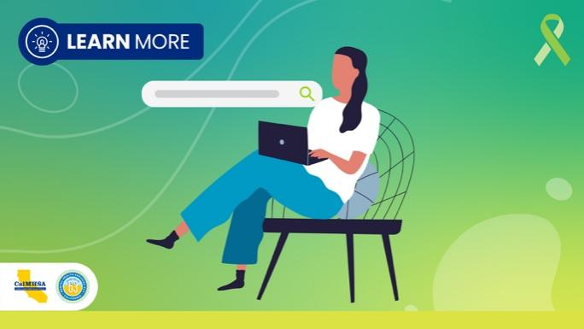  Here's another action you can take for #MentalHealthMonth: #LearnMore about mental health needs and explore the self-care, services, and supports available to help find a path forward. Visit smcmentalhealthmonth.org to get started. #SMCTakeAction4MH
May 17 | May 20
#GetSupport for your own mental health, or help someone else find help, by reaching out and connecting with resources available in San Mateo County! Visit smcmentalhealthmonth.org for helpful resources.  #SMCTakeAction4MH | 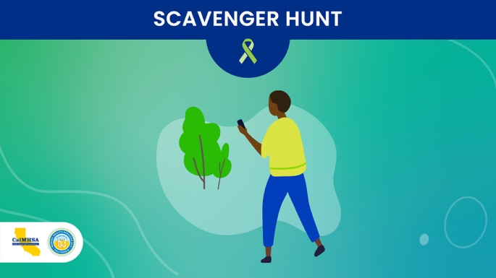  Get ready for the #MentalHealthMattersMonth Scavenger Hunt! Get outside and discover places and activities that can help you engage in Self Care or support others. More here: https://takeaction4mh.com/ #TakeAction4MH
May 24 | May 27
https://youtu.be/NbgPe84xw2A  There’s still time to support your communities’ mental wellness! May is Mental Health Month and California’s theme this year is Take Action! That means takes action to improve your and your love ones’ mental health.  Learn more about ways you can take action by visiting smcmentalhealthmonth.org.  #SMCTakeAction4MH | 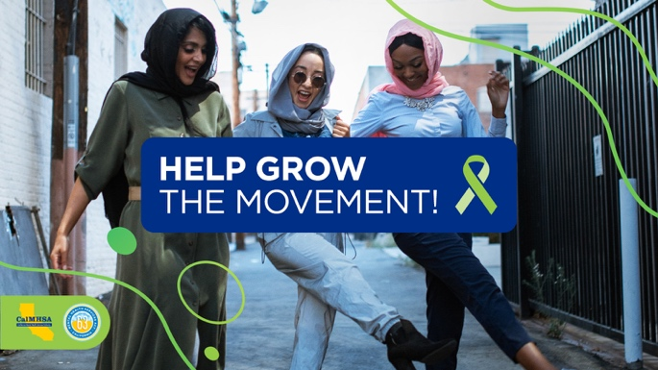  Help grow the movement to Take Action For Mental Health in California! RT to your network, Make The Pledge & show your support for people experiencing a crisis https://takeaction4mh.com/ #SMCTakeAction4MH
May 31
[Thank you for celebrating MHM post coming soon!]

